**Cloud Computing Lab**

**Nayab Khazin**

**BSE-V B**

**2023-BSE-046**

**LAB 11**

# Task 0 Lab Setup (Codespace & GH CLI)

* taskA_codespace_create_and_list.png



* taskA_codespace_ssh_connected.png

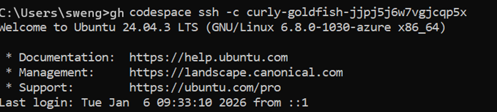

# Task 1 — Provider & Basic variable (variable precedence)

* task1_touch_main_tf.png



* task1_main_tf_provider.png

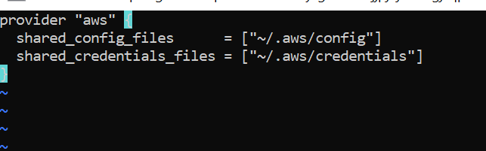

* task1_terraform_init.png

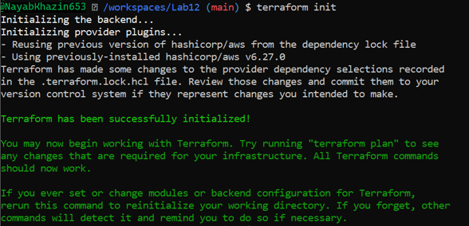

* task1_variable_and_output_added.png

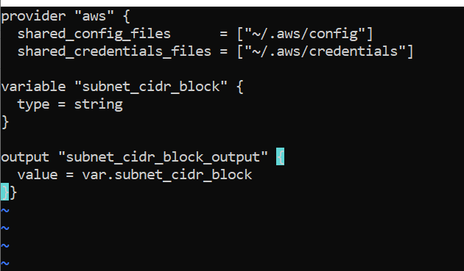

* task1_apply_prompt_for_var.png

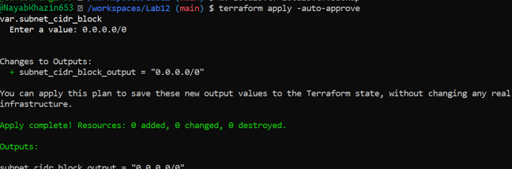

* task1_apply_with_default.png

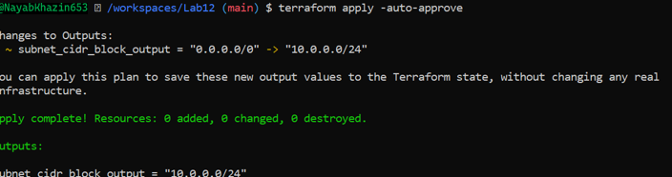

* task1_env_var_set_and_apply.png

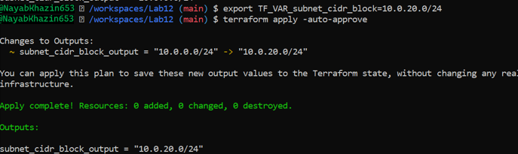

* task1_terraform_tfvars_and_apply.png

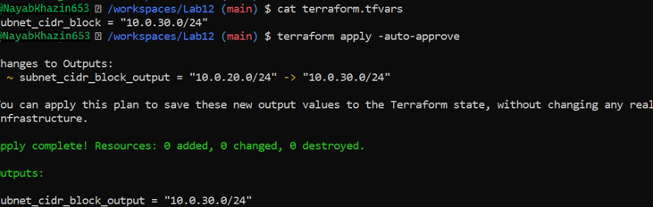

* task1_var_override_with_dash_var.png

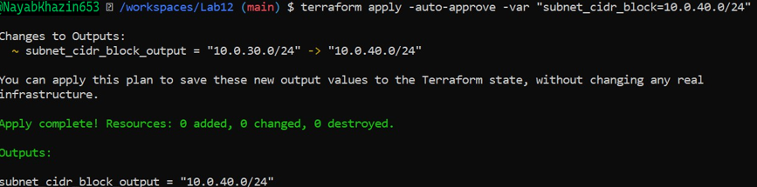

* task1_printenv_tf_var_and_unset.png

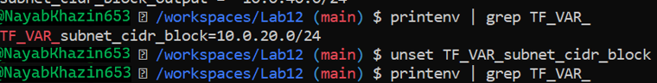

# Task 2 — Variable validation & sensitive / ephemeral variables

* task2_subnet_variable_with_validation.png

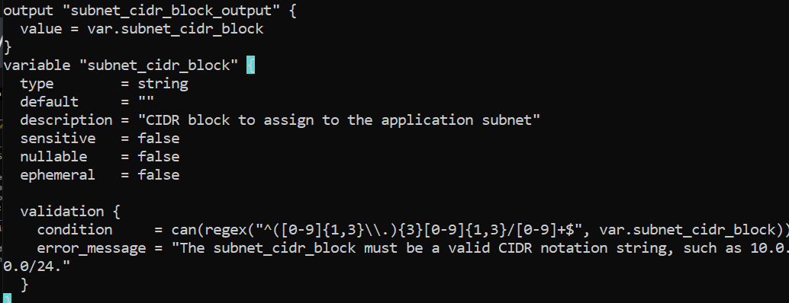

* task2_subnet_validation_error.png

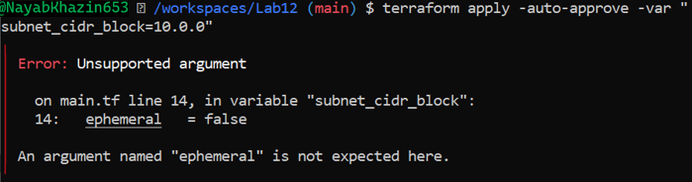

* task2_api_token_variable_added.png

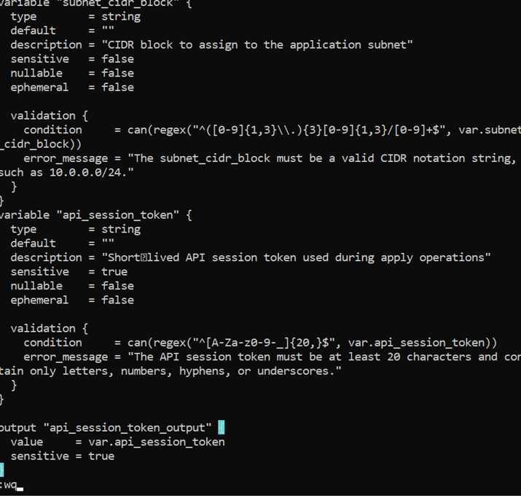

* task2_api_token_apply_sensitive.png

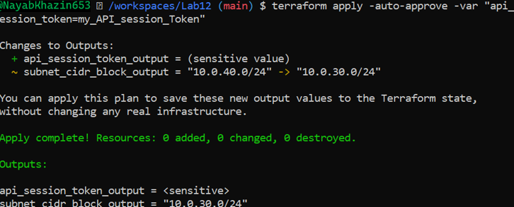

* task2_check_terraform_state_api_token.png

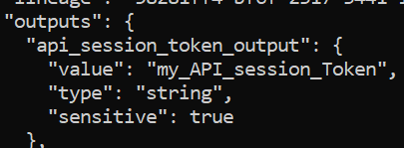

* task2_api_token_ephemeral_error.png

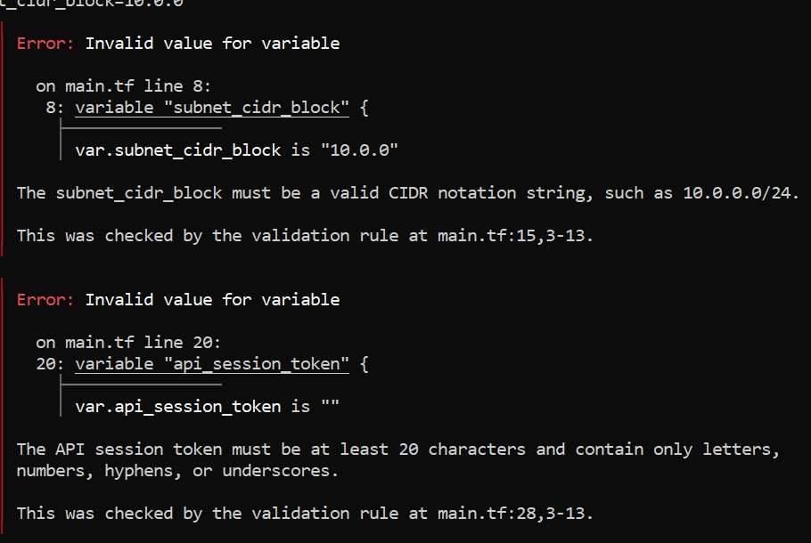

* task2_api_token_default_apply.png

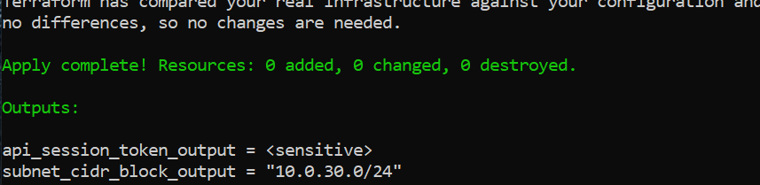

# Task 3 — Project-level variables, locals, and outputs

* task3_variables_added.png

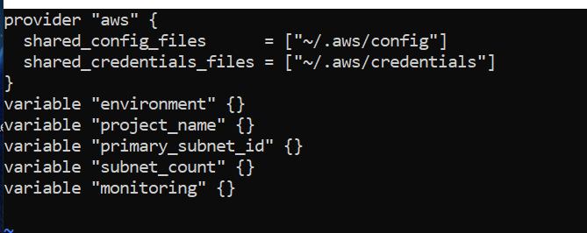

* task3_terraform_tfvars_populated.png

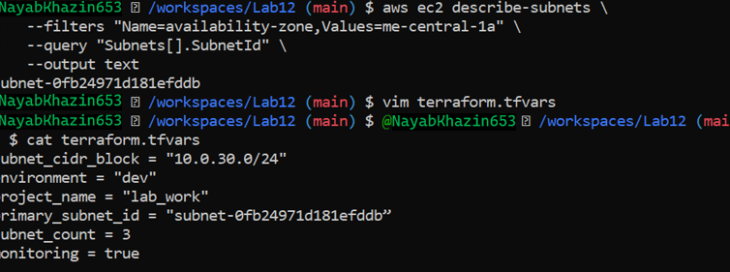

* task3_locals_tf_created.png

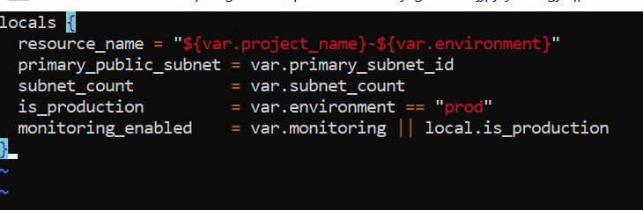

* task3_outputs_apply.png

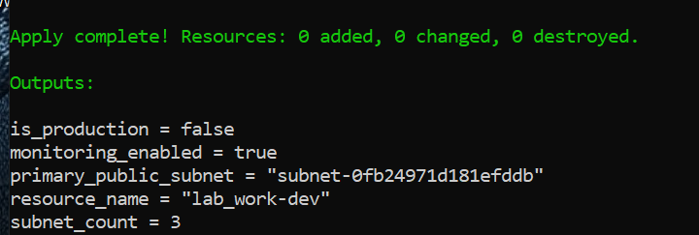

# Task 4 — Maps and Objects

* task4_tags_variable_added.png

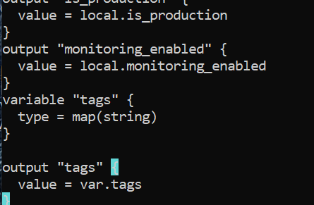

* task4_tags_output.png

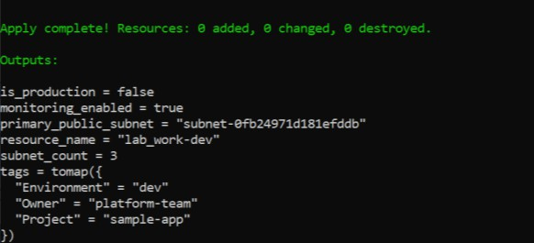

* task4_server_config_output.png

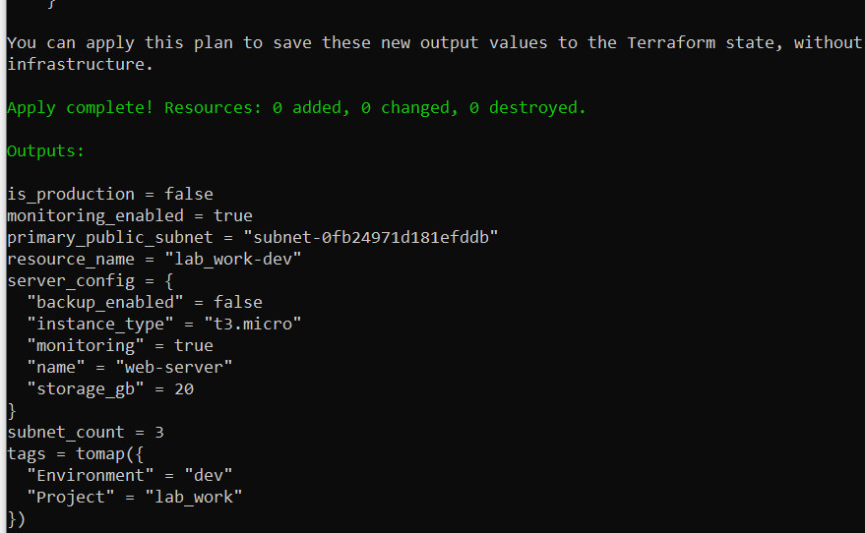

# Task 5 — Collections: list, tuple, set & mutation via locals

* task5_collections_defined.png

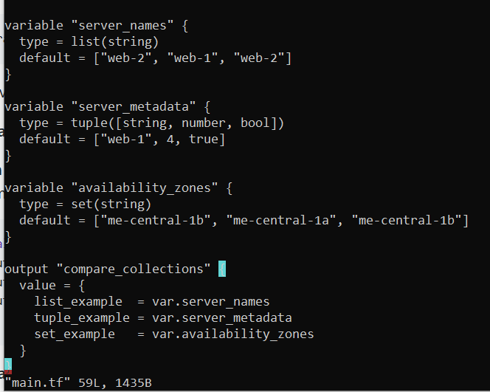

* task5_compare_collections.png

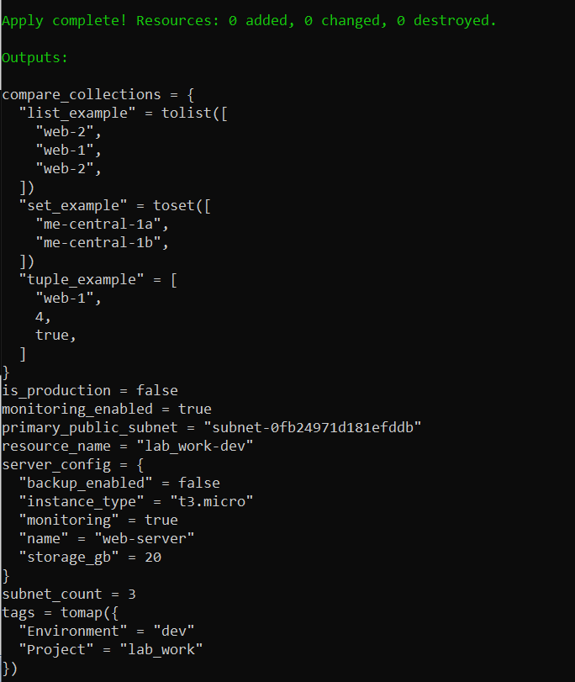

* task5_locals_mutations.png

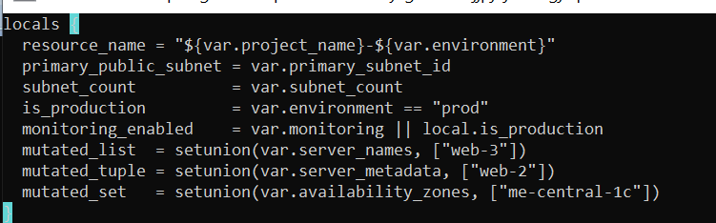

* task5_mutation_comparison.png

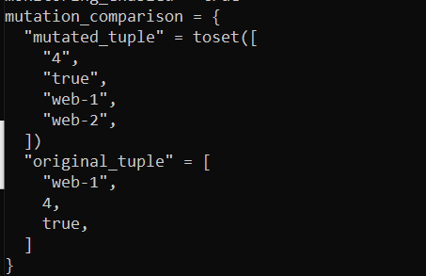

# Task 6 — Null, any type & dynamic values

* task6_optional_tag_variable.png

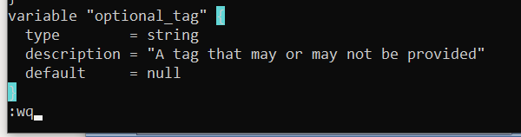

* task6_locals_merge.png

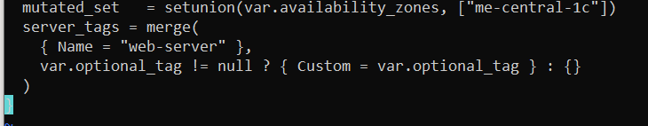

* task6_optional_tag_no_value.png

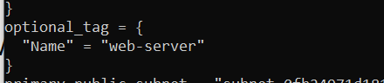

* task6_optional_tag_with_value.png

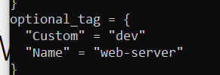

* task6_dynamic_value_string.png

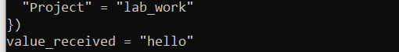

* task6_dynamic_value_number.png



* task6_dynamic_value_list.png

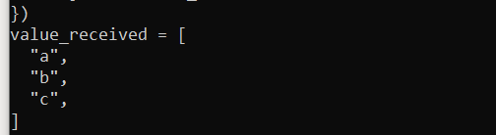

* task6_dynamic_value_map.png

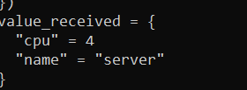

* task6_dynamic_value_null.png(previous outputs only)

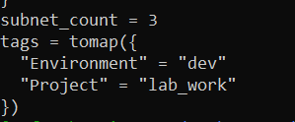

# Task 7 — Git ignore

* task7_gitignore_created.png

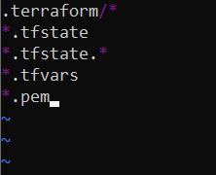

# Task 8 — Clean-up then build real infra (VPC, Subnet, IGW, routing, default route table)

* task8_clean_files.png

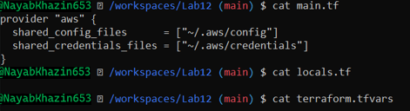

* task8_variables_recreated.png

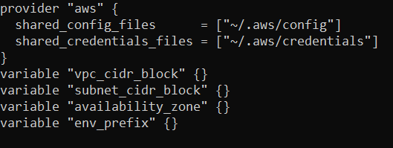

* task8_vpc_resources_added.png

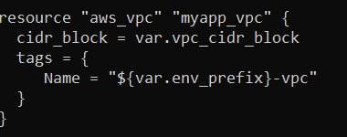

* task8_subnet_resources_added.png

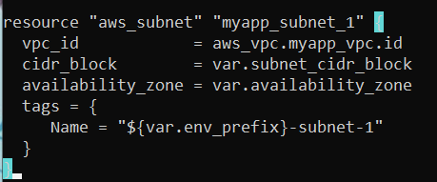

* task8_terraform_tfvars_vpc_values.png

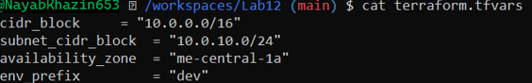

* task8_vpc_subnet_apply.png

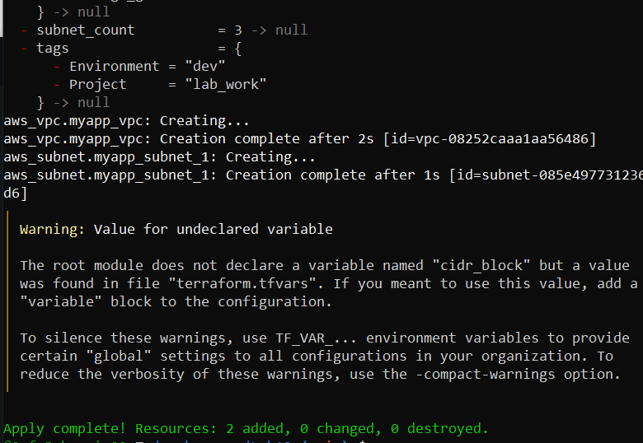

* task8_igw_route_table_before_apply.png

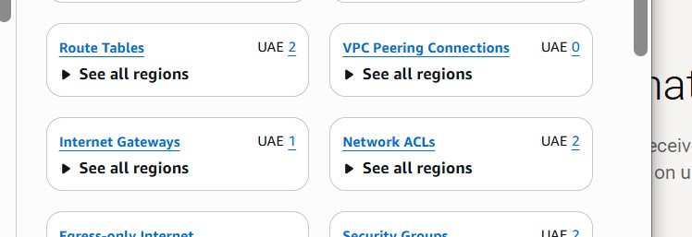

* task8_igw_route_table_after_apply.png

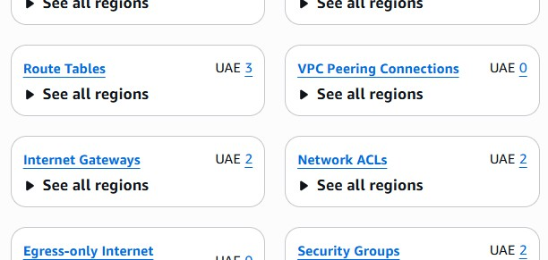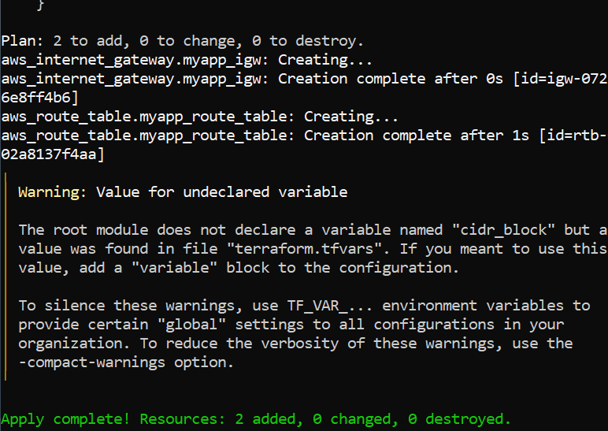

* task8_association_apply.png

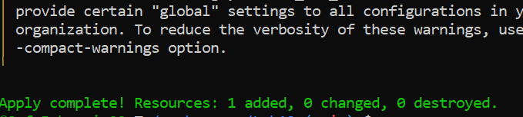

* task8_default_route_table.png

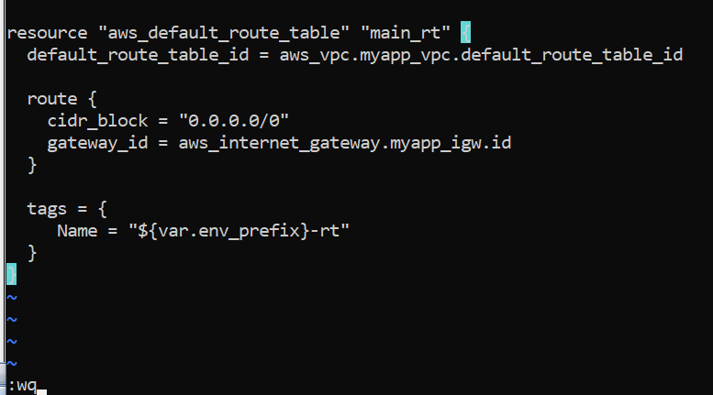

* task8_default_route_table_apply.png

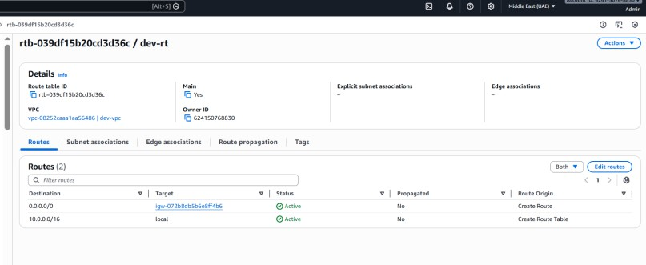

# Task 9 — Security Group, Key Pair, EC2 Instance, user_data & nginx

* task9_my_ip_variable_added.png

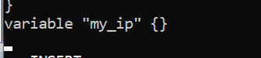

* task9_public_ip_curl.png

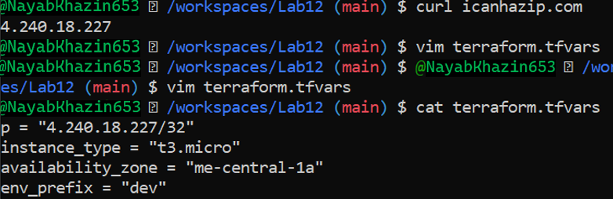

* task9_security_group_apply.png

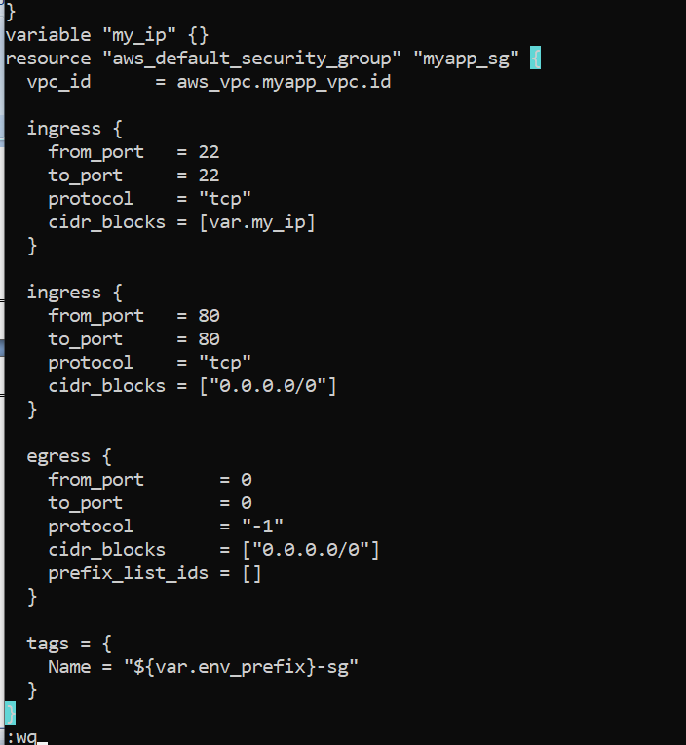

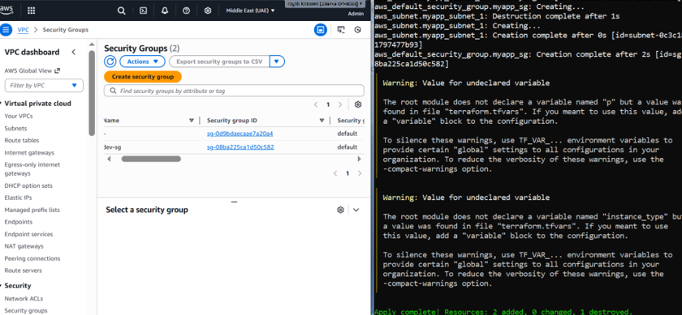

* task9_keypair_created_and_saved.png

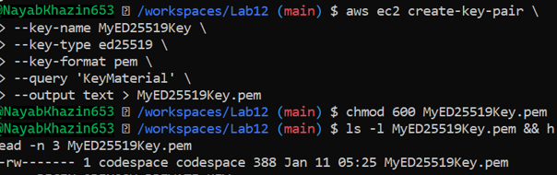

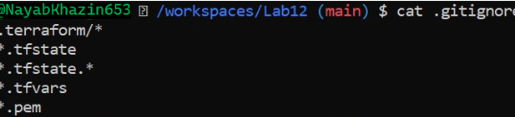

* task9_instance_type_set.png

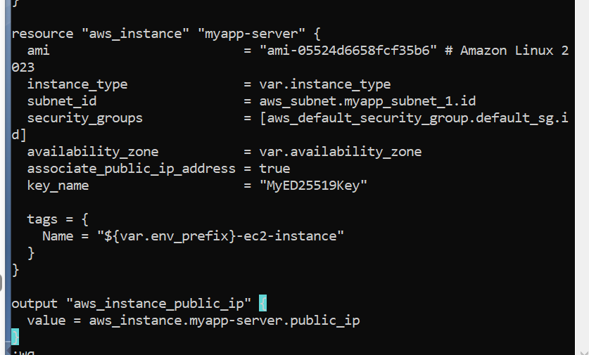

* task9_ec2_apply_and_public_ip.png

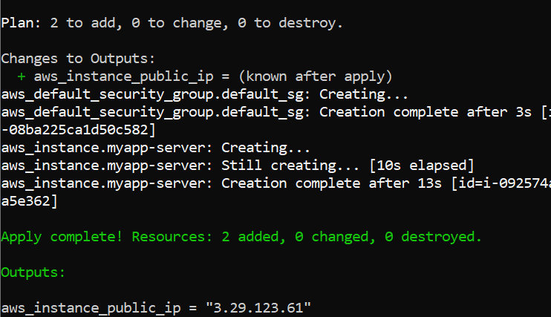

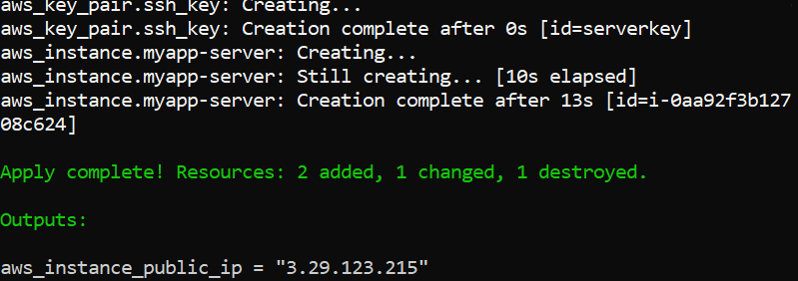

* task9_ssh_into_ec2.png

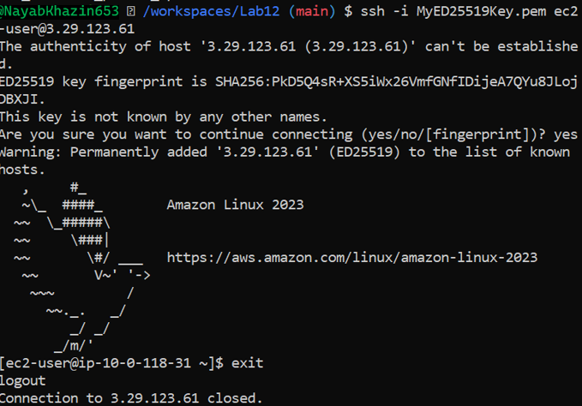

* task9_ssh_keypair_and_ssh.png

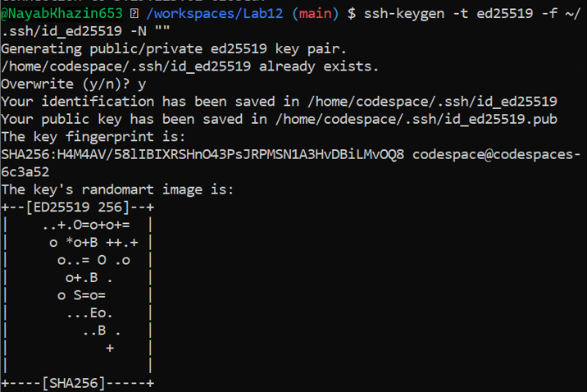

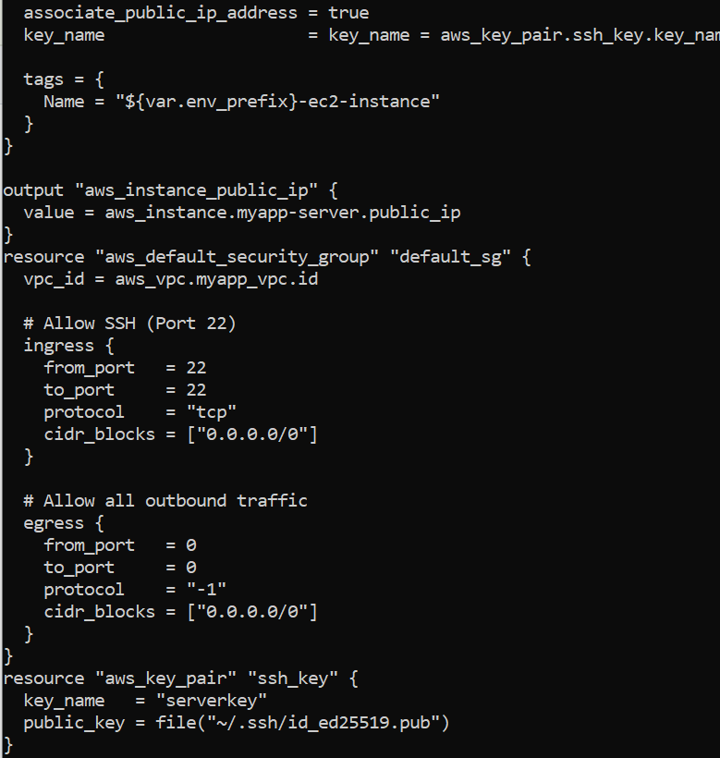

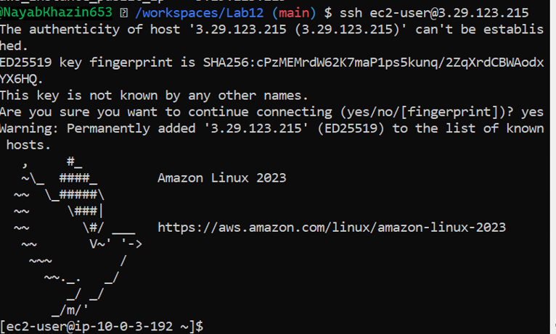

* task9_nginx_local_curl.png

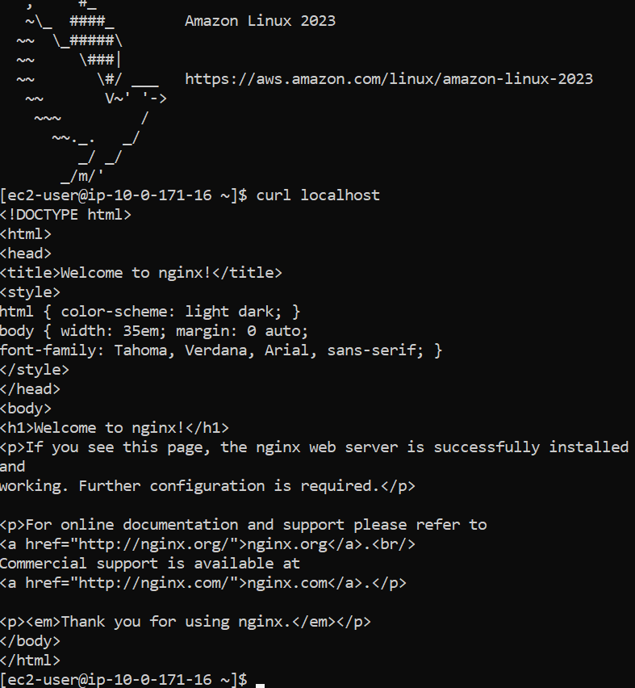

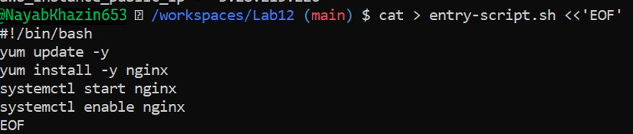

* task9_nginx_browser_page.png

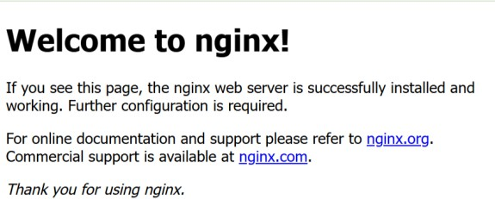

# Cleanup

* cleanup_destroy.png

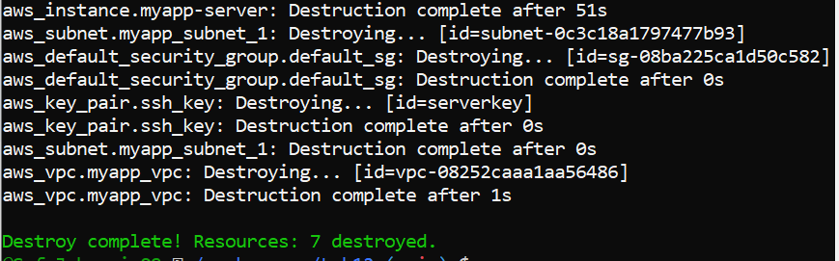

* cleanup_state_files.png

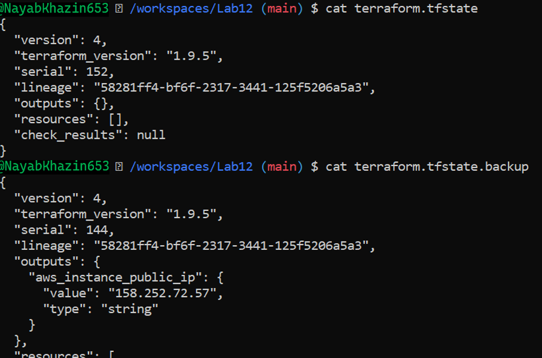

* cleanup_verify_no_secrets.png

